SORT

# Rules

Array sorted DESCENDING. While all algorithms are sorting these array ASCENDING.  
So the execution time would take the worst-case scenario.

# Execution Time

# Complexity Analysis

## Merge Sort

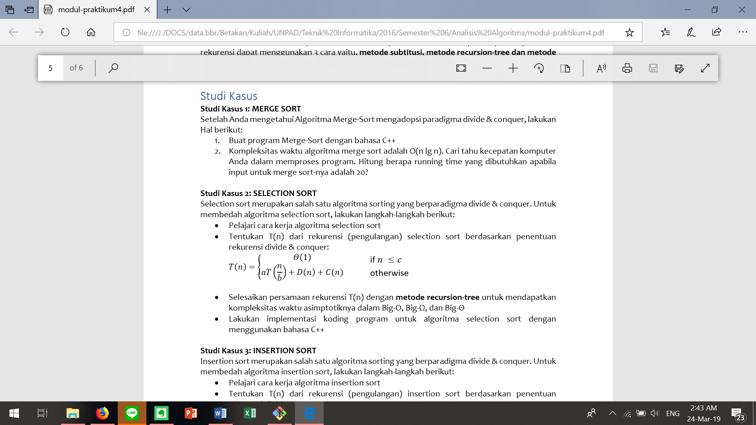

T(n)